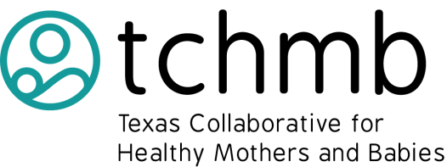

TCHMB 2020 Summit: Making Quality Improvement Local

February 27-28, 2020
AT&T Executive Education and Conference Center, Austin, Texas

Host Opportunities

$10,000-$15,000 Gold Summit Host (2 available)
- Host sponsors a session of the summit (either the QI session or Obstetrics emergency simulation)
- Listing in online conference registration system
- Recognition on all summit signage
- Listing on conference announcement slideshow displayed throughout event
- Acknowledgement in all press releases
- 10 complimentary registrations for the summit

$5,000-$9,000 Silver Summit Host (4 available)
- Host supports conference related expenses
- Listing in online conference registration system
- Recognition on all conference signage
- Listing on conference announcement slideshow displayed throughout event
- 5 complimentary registrations for the summit

$2,500-$4,000 Bronze Summit Host (6 available)
- Host supports conference related expenses
- Listing in online conference registration system
- Recognition on all summit signage
- Listing on conference announcement slideshow displayed throughout event

Contact: Sheena Abraham, sabraham@utsystem.edu, (512) 664-9056

